Integrating SSR Markers and Generation Mean Analysis for the Detection of Yr Genes in Two Bread Wheat Crosses
Abdelgani, Asmaa Mohamed¹, Bekhit, Makhlouf ², El-Garhy, Hoda A. S ², Gad, Khaled Ibrahim¹
¹Field Crops Research Institute, Agricultural Research Center
² Genetics and Genetic Engineering Department, Faculty of Agriculture, Benha University
Corresponding author: asmaaalagamy4@gmail.com

Abstract
The inheritance of yield and its contributing traits was studied utilizing generation mean analysis across six populations (parents, F₁, F₂, and backcrosses) from two bread wheat crosses (Misr 1 x Yr8 and Misr 1 x Yr15) over three seasons (2020/2021 to 2022/2023) at Sakha Agricultural Research Station, Agricultural Research Center, Egypt. The results showed that all traits were quantitatively inherited, with dominant effects usually stronger than additive ones. The only characteristics that weren't quantitatively inherited were spike length, number of spikes per plant, and grain yield in cross-one. Broad-sense heritability values varied from moderate to high, indicating significant heritable variation, while narrow-sense heritability was low for most traits, making selection challenging for traits heavily influenced by the environment. Grain yield in cross 1 showed moderate genetic advance (32.44%), suggesting effective early-generation selection. Genotypes clustered by genetic background, with Yr15 and BC1 in cross 2 identified as promising candidates for breeding due to valuable alleles for traits like kernel weight and spike length.
Keywords: Wheat, Six parameters, heterosis, gene action, genetic advance, heatmap

Introduction

Wheat is a cornerstone crop in global agriculture, acting as a major source of calories and protein for a large segment of the world's population (Khalid et al., 2023). Wheat's importance is even more pronounced in Egypt, where it is a staple food and a critical component of the national diet (Abdalla et al. 2023).
Egypt is the world's largest wheat importer, consuming over 20 million metric tons annually, with domestic production covering around 8 to 9 million metric tons (USDA 2024). This heavy reliance on wheat underscores the importance of continuous improvement in wheat.
Furthermore, Population growth, climate change, and both biotic and abiotic stresses on wheat production are contributing to the widening gap between wheat consumption and production (Martínez-Moreno et al., 2022). As a result, increasing wheat production has become a critical necessity to address this growing gap and ensure global food security. Climate change and abiotic stresses are significant challenges to production efforts, as they both lead to substantial reductions in yield (Walid et al., 2020).
One of the most severe biotic stresses around the world is yellow rust; it is the most prevalent wheat disease that threatens wheat production by causing significant damage in many parts of the world (Nsabiyera et al., 2018).
Stripe rust (Yellow rust) can lead to yield losses ranging between 10% and 70%, with total crop failure (100% loss) possible if the infection starts during the early growth stages and continues unchecked throughout the growing season. (Ashmawy and Ragab, 2016; Afzal, 2007)
Employing genetic resistance to manage yellow rust is both cost-effective and environmentally sustainable, as it eliminates the need for additional inputs while providing long-term control over the disease. (Feng et al., 2018).
Developing resistant varieties remains the most practical and sustainable strategy for managing yellow rust, as it eliminates additional costs for farmers and ensures environmental safety by reducing reliance on chemical controls.
More than one hundred Yr genes have been identified in wheat, with 84 of these receiving formal nomenclatures. Of these, over 70% are categorized as all-stage resistance (ASR) genes, offering protection throughout the entire life cycle of the plant, while the remainder are adult-plant resistance (APR) genes, which are effective during later growth stages. The primary sources of these resistance genes are wild and common wheat species, making them essential for breeding programs aimed at improving resistance to diseases like yellow rust. (Zhang et al. 2023)
Therefore, the integration of the Yr gene in breeding programs would be valuable for the production of new wheat cultivars for long-term control of stripe rust.
Simple Sequence Repeats (SSRs) are increasingly becoming the preferred markers in breeding programs of plants due to their many advantages. They are transferable, multi-allelic, and co-dominant, meaning they can detect variations in both alleles of a gene. Being PCR-based, they are easy to reproduce and are randomly distributed across the genome. These capabilities make SSRs a powerful tool for enhancing wheat breeding and improving crop characteristics. (Sari et al. 2023).
Generation Mean Analysis is a quantitative biometric method that involves measuring the phenotypic performance of quantitative traits across parents, backcross, and segregating generations. According to Kearsey and Pooni (1996), this technique is considered to be valuable in plant breeding for estimating the main gene effects—additive and dominance—as well as the interactions between them (additive × additive, additive × dominance, and dominance × dominance) that control the inheritance of quantitative traits. It is particularly useful for evaluating the potential of crosses, either for exploiting heterosis or for pedigree selection (Sharma et al., 2003).
Genetic information gathered from multiple generations provides more consistent insights than data from a single generation. Using A, B, C, and D scaling tests, both additive, dominance, and epistatic effects were found to play significant roles in determining yield and its components. Previous studies have also shown that additive and dominant genetic factors are key contributors to most plant traits in wheat. (Raikwar et al. 2024)
This study aims to cross an Egyptian wheat variety with two lines carrying Yr genes for resistance to yellow rust, concentrating on the study of inbreeding depression, heterosis, and the type of gene action that contributes to the inheritance of specific agronomic traits and grain yield.
The research is utilizing the six-parameter model to estimate the genetic effects, including additive, dominance, and their interactions. Additionally, the study will track the presence of yellow rust resistance genes in the F₂ generation and backcrosses to better understand their role in inheritance and their potential use in breeding programs aimed at improving disease resistance and yield stability.
This approach will help provide deeper insights into the genetic dynamics of wheat breeding, contributing to the development of more resilient and high-yielding wheat varieties.

Materials and methods
Plant material
This study’s field experiment was carried out at Sakha Agricultural Research Station, Kafrelsheikh, Governorate, Egypt, during the following seasons: 2020/2021, 2021/2022, and 2022/2023.
Three bread wheat genotypes were chosen for the research, depending on their resistance to yellow rust, genetic diversity, and origin (Table 1).

Table (1): Pedigree and origin of the studied wheat genotypes
Name | Pedigree | Yellow rust field response† | Origin
Misr 1 | OASIS/SKAUZ//4*BCN/3/2*PASTOR CMSS00Y01881T-050M-030Y-030M-030WGY-33M-0Y-0S | 100S | Egypt
Yr 8 | Yr8/6*AOC | 0 | CIMMYT
Yr 15 | Yr15/6*AOC | 0 | CIMMYT
†0 = Immune and S = Susceptible (characterized by a large number of uredinia, no necrosis, although chlorosis may be visible).

During the 2020/2021 growing season, the Egyptian bread wheat cultivar (Misr1) was planted alongside the two Yr monogenic lines across three different planting dates to ensure flowering in tandem. Each genotype was planted in 2 rows, each 2.5 meters long, on each planting date. Misr1 was crossed with the two resistant parents carrying the Yr8 and Yr15 genes to produce F₁ seeds. In the 2021/2022 growing season, some of the F1 plants were backcrossed to their respective parents to generate BC₁ (F₁ x P₁) and BC₂ (F₁ x P₂) generations. More F₁ seeds were produced by further crosses, and the F₂ generation was produced by self-pollinating some F₁ hybrids.
In season 2022/2023, all seeds were planted in a field experiment. The six populations, P₁, P₂, F₁, F₂, BC₁, and BC₂, resulting from the four crosses, were arranged in a randomized complete block design with three replications. Each replicate consisted of 44 rows: 16 rows for F₂, 8 rows for each BC₁ and BC₂, and 4 rows for each P₁, P₂, and F₁. Each row measured 4 meters in length, with 30 cm spacing between rows and 20 cm spacing between plants.
Thirty plants for non-segregating populations, 60 plants for BC₁ and BC₂ segregation populations, and 120 plants for the F₂ segregating populations were randomly selected for recording of data on eight traits, namely: days to heading (50%), days to maturity (50%), plant height (cm), spike length (cm), number of spikes/plant (No. S/P), number of grains/spike, 1000-kernel weight (g), and grain yield/plant (g).
To guarantee even distribution of the Pst inoculum, a highly susceptible spreader wheat cultivar (Morocco) was planted around the experimental field. Fertilization, pest control, and other cultural practices followed standard wheat production recommendations, maintaining consistent and uniform conditions throughout the experiment.
Biometrical analysis
The percentage of F₁ hybrids' deviation from their mid-parent (MP) or better parent (BP) values was used to estimate heterosis. According to Peter and Frey (1966), inbreeding depression was calculated as the average percentage decrease of the F₂ from the F₁. The scaling tests A, B, C, and D were calculated using the variances and the population means. The adequateness of the additive-dominance model for various traits in each cross was assessed using a scaling test (Hayman and Mather 1955). Any one of these scales' significance was interpreted as a sign of epistasis, or nonallelic interaction. According to Mather (1949) and Hayman and Mather (1955), six parameters were employed for estimating different gene effects in the presence of non-allelic interaction and to determine the type of gene effects. Various gene effects were estimated using Gamble's (1962) six-parameter model. Mather (1949) calculated heritability in both its broad and narrow senses, and Johnson et al. (1955) calculated the expected genetic advance under selection.
Molecular marker analyses:
DNA Extraction and Quantification:
DNA was extracted from young leaves of each genotype based on the method advised by Kalender et al (2021). One sample from the two parents and F₁ plants, six bulked samples from F₂, and 7 bulked samples from each backcross.

Single sequence repeats (SSR) analysis:
The six populations of the two crosses were examined for the presence of yellow rust resistance genes using two SSR markers associated with these genes (Table 2).

Table (2). The codes, sequences and annealing temperature for both SSR primers.
Gene | Primer | Primer sequence  (5′ to 3′) | Annealing Temperature | fragment size  bp+ | (bp-) | Reference
Yr 8 | Xgwm157 | F: GTCGTCGCGGTAAGCTTG | 60 | 120 |  | Dawit et al. 2019
Yr 8 | Xgwm157 | R: GAGTGAACACACGAGGCTTG | 60 |  |  | Dawit et al. 2019
Yr 15 | barc8 | F:GCGGGAATCATGCATAGGAAAACAGAA | 56 | 200 | 280 | Murphy et al. (2009)
Yr 15 | barc8 | R:GCGGGGGCGAAACATACACATAAAAACA

The PCR reaction was done in a 30 ml reaction total volume containing 3.0 μl of template DNA (20 ng/μl concentration), 15 μl of master mix, 2 μl of primer from each (forward and reverse), and up to 30 μl of distilled water.
Amplification was carried out in the BERKIN ELMER Gene Amp PCR System 2400. The program is as follows:
For primer 1 (Yr 8), 94 for 5 min hot start; 35 cycles (94°C for 30 seconds, 60°C for 30 seconds, 72°C for 30 seconds) and 72°C for 7 min, then at 4°C.
For primer 2 (Yr 15), 94 for 5 min hot start; 35 cycles (94°C for 30 seconds, 56°C for 30 seconds, 72°C for 30 seconds) and 72°C for 7 min, then at 4°C.
A solution of 0.5 mg/ml ethidium bromide kept at room temperature was used to stain the gels. After mixing the samples with 1x loading buffer, they were loaded into the gel's slots. On a 2% agarose gel in 1xTHE buffer, electrophoresis was carried out for three to four hours at a steady voltage of 70 volts. The Alfa Imager 2001 gel documentation system (Alfa Infotech Biosystems, USA) was utilized in the local laboratory. Electrophoresis Gene Ruler TM DNA ladder mix (Thermo Scientific), diluted with 1x gel loading buffer to a final concentration of 25 ng/µl, with a base range of 100–10,000.
To find the molecular size of the DNA bands, 3 μl of the 100 bp DNA ladder was utilized.
Heatmap and Biplot:
Heatmaps were created using ClustVis, a web tool for visualizing the clustering of multivariate data (https://biit.cs.ut.ee/clustvis/). Metsalu, T. and Vilo, J. (2015) used PAST software version 4.02 to create a PCA scatter diagram based on a Dice coefficient genetic similarity matrix (Hammer et al. 2001).

Results and discussion
Mean performance
In the two crosses, the mean values of the six populations for all examined traits showed significant differences, indicating that there is enough genetic variation for these traits in the material under study (Table 3).

Table (3) Mean performance of parents, F₁, F₂, and back crosses generations in two wheat crosses for all studied traits.
Generation | Traits
Generation | DH | DM | PH(cm) | Number of spikes plant-1 | Spike length (cm) | Number of grain per spike | 1000 kernel weight (g) | Grain yield plant⁻¹(g)
cross one (Misr 1 X Yr 8)
P₁ | 93.53 ± 2.50 | 135.07 ± 0.14 | 97.57 ± 0.55 | 14.67 ± 0.60 | 10.07 ± 0.15 | 66.90 ± 0.76 | 40.34 ± 0.71 | 41.05 ± 2.50
P₂ | 92.13± 0.09 | 136.87 ± 0.18 | 117.73 ± 0.25 | 20.17 ± 0.30 | 10.35 ± 0.15 | 70.20 ± 0.71 | 42.72 ± 0.68 | 61.81 ± 1.62
F₁ | 92.97± 0.16 | 135.73 ± 0.17 | 111.93 ± 0.76 | 17.90 ± 0.89 | 9.37 ±0.10 | 66.20 ± 0.76 | 47.04 ± 0.65 | 55.73 ± 2.91
F₂ | 91.68 ±0.15 | 133.36 ± 0.14 | 106.97 ± 0.99 | 25.47 ± 0.53 | 9.86 ± 0.12 | 76.48 ± 0.94 | 42.38 ± 0.40 | 83.30 ± 2.15
BC₁ | 91.43±0.19 | 137.05 ± 0.20 | 106.13 ± 1.02 | 22.30 ± 0.70 | 9.88 ± 0.09 | 70.45 ± 1.18 | 41.57 ±0.51 | 59.95± 2.72
BC₂ | 91.82 ± 0.18 | 136.13 ± 0.11 | 111.83 ± 1.19 | 24.88 ±0.64 | 9.96 ± 0.18 | 72.45 ± 1.01 | 37.05 ± 0.56 | 65.50 ± 2.24
L.S.D _{(0.05)} | 1.70 | 1.81 | 8.35 | 9.75 | 1.14 | 8.33 | 7.07 | 31.84
cross two (Misr 1 X Yr 15)
P₁ | 95.20 ± 0.18 | 135.30 ± 0.09 | 101.53 ± 0.59 | 14.60 ± 0.57 | 10.07 ± 0.15 | 65.30 ± 0.51 | 40.44 ± 0.73 | 38.73 ± 1.88
P₂ | 95.00 ± 0.19 | 136.70 ± 0.20 | 120.87 ± 0.28 | 21.10 ± 0.56 | 12.37 ± 0.16 | 45.60 ± 0.26 | 44.96 ± 0.77 | 42.02 ± 1.72
F₁ | 94.37± 0.18 | 135.80 ± 0.10 | 101.73 ± 0.56 | 19.87 ± 0.52 | 11.13 ± 0.17 | 46.53 ± 0.25 | 38.96 ± 0.74 | 41.25 ± 1.61
F₂ | 92.85 ±0.14 | 134.90 ± 0.20 | 111.11 ± 0.73 | 23.25± 0.30 | 11.12 ± 0.11 | 46.90 ± 0.34 | 38.10 ± 0.51 | 47.00 ± 1.10
BC₁ | 94.47 ±0.19 | 135.73 ± 0.22 | 120.55 ±0.78 | 14.02 ±0.40 | 11.28 ± 0.14 | 46.83 ± 0.37 | 40.83 ± 0.78 | 47.16 ± 1.50
BC₂ | 95.37 00.19 | 134.63 ± 0.22 | 114.30 ± 0.78 | 16.08 ± 0.44 | 11.42 ± 0.15 | 46.53 ± 0.45 | 36.40 ± 0.58 | 50.20 ± 1.48
L.S.D (0.05) | 2.00 | 1.10 | 6.15 | 5.72 | 1.91 | 2.77 | 8.11 | 17.67
DH= Days to heading, DM=Days to maturity, PH= plant height (cm)

The F₁ means exceeded the mid-values of the two parental means in cross 1 (Misr 1 X Yr8) for the following traits: days to heading (DH), plant height (cm), number of spikes/plant, number of grains/spike, 1000-kernel weight (g), and grain yield/plant (g). Regarding cross 2 (Misr 1 X Yr 15), the F₁ means were more than the mid-values of the two parental means for only the number of spikes/plant and grain yield/plant (g). These results reflect the presence of dominance towards the better parent, while it was lower than the mid-parent for days to maturity, spike length (cm), and number of grains per spike in cross 1 and for days to heading, days to maturity, plant height (cm), spike length (cm), number of grains/spike, and 1000-kernel weight (g) in cross 2. That indicates partial dominance for these traits.
The mean values of the F₂ population were below the F₁ mean values and in the middle of the two parents for all studied traits except the first cross in each of the number of spikes plant⁻¹, spike length (cm), number of grains per spike, and grain yield plant⁻¹ (g); and except for the number of spikes plant⁻¹ and grain yield plant⁻¹ (g) for cross 2. Indicating that these characters are quantitatively inherited.
In Cross 2 (Misr 1 X Yr15), the F₁ means were higher than the mid-parent values only for the number of spikes per plant and grain yield plant-1 (g). For the other traits, the F₁ values were again lower than the mid-parent values, indicating partial dominance for these traits.
For the F₂ population, the means were generally intermediate between the two parental means and lower than the F₁ mean values for most traits. Exceptions were noted for the number of spikes per plant, spike length (cm), number of grains per spike, and grain yield per plant (g) in cross 1, as well as for the number of spikes per plant and grain yield per plant (g) in cross 2. These findings suggest that these traits are quantitatively inherited.
However, the mean values for both BC₁ and BC₂ generally trended, with a few exceptions, toward the mean of the recurrent parent for the traits under study. Manal H. Eid (2009), Koumber and El-Gammaal (2012), and Hamam (2013) have all reported similar results.
Results revealed that the variances for the non-segregating populations (P₁, P₂, and F₁) were notably lower than those for the segregating populations (F₂, BC₁, and BC₂). This means the non-segregating populations are genetically uniform, whereas the F₂ and backcross populations are genetically diverse and show higher diversity. This is to be expected since mixtures of heterozygous plants are present in the segregating populations. These results align with Said (2014).
Scaling test
Table 4 presents the results of testing non-allelic interactions (A, B, C, and D) alongside the six-parameter model and the types of epistasis. It is noteworthy that at least one of the A, B, C, or D tests showed significance for all studied traits, except for days to heading, plant height, spike length (cm), and 1000 kernels weight (g) in cross 1 (Misr 1 × Yr 8), and for days to maturity, number of grains per spike, and 1000 kernels weight (g) in cross 2 (Misr 1 × Yr 15).

Table (4): the scaling test and estimates of the six parameters, i.e. means (m), additive (a), dominance (h), additive × additive (i), additive × dominance (j) and dominance × dominance (I), in 2 bread wheat crosses for all the traits.
Trait | Cross | Genetic parameter
Trait | Cross | A | B | C | D | M | A | h | I | J | I
Days to heading | 1 | -3.63 | -1.46 | -4.90 | 0.10 | 91.675** | -0.38 | -0.07 | --- | --- | ---
Days to heading | 2 | -0.63 | 1.37* | -7.53 | -4.13 | 92.85** | -0.90 | 7.53** | 8.27** | -1.00 | -9.00
Days to maturity | 1 | 3.30** | -0.33 | -9.97 | -6.47 | 133.36** | 0.97** | 12.70** | 12.93* | 1.87** | -15.90
Days to maturity | 2 | -0.63 | 1.37* | -7.53 | -4.13 | 92.85** | -0.90 | 7.53** | 8.27** | -1.00 | -9.00
Plant height | 1 | 2.77 | -6.00 | -11.30 | -4.03 | 106.97** | -5.70 | 12.35* | --- | --- | ---
Plant height | 2 | 37.83** | 6.00** | 18.57** | -12.63 | 111.11** | 6.25** | 15.80** | 25.27** | 15.92** | -69.10
No. of Spike/plant | 1 | 12.03** | 11.7** | 31.23** | 3.75 | 25.47** | -2.58 | -7.02 | -7.50 | 0.17 | -16.23
No. of Spike/plant | 2 | -6.43 | -8.80 | 17.57** | 16.4* | 23.25** | -2.07 | -30.78 | -32.80 | 1.18 | 48.03**
Spike length (cm) | 1 | 0.33 | 0.20 | 0.30 | -0.12 | 9.86** | -0.08 | -0.61 | --- | --- | ---
Spike length (cm) | 2 | 1.35** | -0.67 | -0.23 | -0.46 | 11.12** | -0.14 | 0.83 | 0.92 | 1.01** | -1.60
No. of grains /spike | 1 | 7.80** | 8.5** | 36.4** | 10.05 | 76.48** | -2.00 | -22.45 | -20.10 | -0.35 | 3.80
No. of grains /spike | 2 | -18.17 | 0.93 | -16.37 | 0.43 | 46.9** | 0.30 | -9.78 | --- | --- | ---
1000 kernels weight(g) | 1 | -4.24 | -15.66 | -7.63 | 6.13 | 42.38** | 4.52** | -6.76 | --- | --- | ---
1000 kernels weight(g) | 2 | 2.25 | -11.12 | -10.92 | -1.02 | 38.10** | 4.43** | -1.70 | --- | --- | ---
Grain yield/plant (g) | 1 | 23.13** | 13.46* | 118.87** | 41.14 | 83.30** | -5.55 | -77.99 | -82.29 | 4.84 | 45.70*
Grain yield/plant (g) | 2 | 14.35** | 17.13** | 24.74** | -3.37 | 47.00** | -3.03 | 7.61 | 6.74 | -1.39 | -38.22
* and ** indicate significance at the 0.05 and 0.01 levels of probability, respectively.

These results suggest that the six-parameter model is effective in describing the gene's nature. However, the lack of significant results for the measured A, B, C or D indicates that the interactive model was inadequate in explaining the gene action type in such cases. In general, these findings align with those published by Shafey et al. (1993), Tammam (2005), Kattab et al. (2010), El-Aref et al. (2011), Zaazaa et al. (2012), and Ahmed (2021).
Gene effects:
Table (4) lists the six attributes of the gene effect: means (m), dominance (h), additive (a), additive × additive (i), additive × dominance (j), and the third type of epistatic effect dominance × dominance (I). In the two crosses that showed these traits were quantitatively inherited, the mean effects were highly significant for every trait under study.
The effects of the additive gene (a) were highly significant in days to maturity in cross 1, plant height in cross 2, and 1000 kernel weight (g) in both crosses. These particular findings showed the capability of improving the performance of these traits using the pedigree selection program may be more efficient. (Abul-Nass et al. 1993, Hendawy 2003, and Hamam 2014).
The dominance (h) gene effects were positive, highly significant, and higher than the effects of the additive gene for days to heading in cross 1, days to maturity, and plant height in both crosses, illustrating the dominating part of the dominant component of gene action in the inheritance of the traits. Therefore, when the dominant effect decreases, the selection process for those traits should be slowed to a later generation.
These findings demonstrate the influence of dominance gene effects in the inheritance of these characters. Nonetheless, the importance of the dominance (d) and additive (a) components indicated that both dominance and additive gene effects were crucial for the inheritance of these characteristics. Additionally, it may be feasible to choose the desired characters in the early generations, but it works better in the later generations. Hendawy (2003), Fethi and Mohamed (2010), Moussa (2010), Mohamed (2013), and Hamam (2014) all obtained comparable outcomes.
Except for spike length, number of grains/spike, grain yield in cross 1, number of spikes/plant, and 1000 kernel weight in the two crosses, dominance effects were generally larger than additive. These outcomes are consistent with Khaled's (2013) findings.
The additive × additive (i) type of gene effects was highly significant for days to heading and plant height in cross two, but it was positive and significant for days to maturity in both crosses. Cross 1 showed no significant differences in days to heading, spike/plant number, number of grains/spike, and grain yield (g), while Cross 2 showed no significant differences in spike/plant number, spike length (cm), and grain yield (g).
Regarding additive x dominance (j) type of gene action, data in Table 4 revealed that none of the crosses exhibited positive or negative significant additive × dominance effects except it was high positive significant for days to maturity in cross 1 and for plant height and spike length (cm) in cross 2. According to all other traits and crosses, there were no significant additive × dominance effects, suggesting that the interaction between additive and dominant gene actions does not significantly influence these traits in those combinations.
Dominance × dominance epistasis type was significant or highly positive significant for only the No. of spike/plant in cross 1 and for grain yield (g) in cross 2.
Heterosis and inbreeding depression:
Heterosis is a complex trait resulting from the interaction of multiple factors that shape genotypic effects and the distribution of favorable and unfavorable alleles in the parental lines (Hochholdinger and Peng., 2024).
Heterosis was evaluated as the percentage deviation of the mean F1 performance from the better or mid-parent values for the studied traits. Table 5 illustrates the percentages of heterosis relative to the better parent values. Significant positive heterosis was observed for days to maturity and the number of spikes per plant in cross 1, as well as for the number of grains per spike in cross 2 when compared to both mid-parent and better parent values.
Inbreeding depression refers to the decline in performance of the F₂ generation due to inbreeding. The results in Table 5 revealed significant positive inbreeding depression values for all studied traits in both crosses.
Since the expression of heterosis in F₁s was followed by a significant decrease in F₂ performance due to homozygosity, the study's results showed significant effects for both heterosis and inbreeding depression. Furthermore, inbreeding depression is a logical explanation for the decline in values of non-additive genetic components. According to Abd El-Rahman (2013), Zaazaa et al. (2012), and Koumber and El-Gammaal (2012), the findings are consistent.

Table 5: Heterosis and inbreeding depression in two crosses of bread wheat for all studied traits.
Trait | Cross | Heteosis |  | ID%
Trait | Cross | MB% | BP% | ID%
Days to heading | 1 | 0.14 | -0.61 | 1.39**
Days to heading | 2 | -0.17 | -0.83 | 1.73*
Days to maturity | 1 | 3.98** | -4.93** | 4.44**
Days to maturity | 2 | 2.78 | -11.24 | -42.27**
Plant height (cm) | 1 | -8.24 | -9.5 | -5.29**
Plant height (cm) | 2 | -3.43 | -5.7 | -15.52**
No. of Spike/plant | 1 | 13.27** | 10.12** | 9.92**
No. of Spike/plant | 2 | 8.36 | -9.84 | -49.47**
Spike length (cm) | 1 | -0.77 | -0.88 | 1.61**
Spike length (cm) | 2 | -0.15 | -0.66 | 0.66**
No. of grains /spike | 1 | -8.51 | -15.83 | -9.23**
No. of grains /spike | 2 | 11.30** | -5.85** | -17.03**
1000 kernels weight(g) | 1 | -0.74 | -9.97 | 0.15**
1000 kernels weight(g) | 2 | -16.08 | -28.74 | -0.79**
Grain yield/plant (g) | 1 | -8.76 | -13.34 | 2.21**
Grain yield/plant (g) | 2 | 2.17 | -1.84 | -13.94**
* and ** denote significance at 0.05 and 0.01 levels of probability, respectively

Heritability in broad (h²b) and narrow sense (h²n) heritability and expected genetic advance:
Heritability estimates determine how easy or difficult it is to make progress in selecting plant traits within a breeding program. (Schmidt et al. 2019). Heritability evaluation in broad and narrow sense and genetic advance (G.S. %) are shown in Table (6).
The values of heritability in a broad sense were moderate to high for all traits in the two hybrids, ranging from 25.42% for the number of spikes per plant to 85.20% for plant height in cross 1, while it ranged from 28.81% for the number of spikes per plant to 93.89% for days to maturity. This indicates that those traits are significantly influenced by both additive and non-additive effects, showing a substantial amount of heritable variation.
In contrast, values of narrow-sense heritability were generally low to moderate for most studied traits, except for days to heading and number of spikes per plant (1.68% and 2.70%, respectively), which were extremely low. This suggests that selection for these traits will be challenging due to high environmental effects. The findings of El-Aref et al. (2011), Amin (2013), Abd El-Rady (2018), El Massry and El-Nahas (2018), and El-Gammaal and Yahya (2018) are all consistent with these findings.

Table 6: Broad (h²b) and narrow sense (h²n) heritability and expected genetic advance in two bread wheat crosses for all traits.
Trait | Cross | h²b | h²n | Genetic Adv.%
Days to heading | 1 | 72.63 | 21.19 | 1.27
Days to heading | 2 | 54.51 | 1.68 | 0.09
Days to maturity | 1 | 67.63 | 48.53 | 1.29
Days to maturity | 2 | 93.89 | 43.28 | 2.47
Plant height (cm) | 1 | 85.20 | 34.33 | 13.31
Plant height (cm) | 2 | 85.06 | 42.58 | 10.66
No. of Spike/plant | 1 | 28.81 | 20.94 | 15.28
No. of Spike/plant | 2 | 25.42 | 2.70 | 1.46
Spike length (cm) | 1 | 80.28 | 21.70 | 14.14
Spike length (cm) | 2 | 33.93 | 5.98 | 2.43
No. of grains /spike | 1 | 83.53 | 34.91 | 14.73
No. of grains /spike | 2 | 86.18 | 22.89 | 7.34
1000 kernels weight(g) | 1 | 36.58 | 12.38 | 4.87
1000 kernels weight(g) | 2 | 46.63 | 10.80 | 4.01
Grain yield/plant (g) | 1 | 54.46 | 37.62 | 32.44
Grain yield/plant (g) | 2 | 45.94 | 7.96 | 7.02

The percentage of genetic advance of the F₂ means for all the studied traits is shown in Table 6. Moderate genetic advance was shown for grain yield (g) (32.44%) in cross 1 so Selection in this cross is expected to be both effective and suitable during the early generations, contributing to the success of breeding programs.
Meanwhile, it was low for the number of spikes/plant, spike length (cm), plant height, and number of grains/spike (15.28%, 14.14%, and 13.31%, respectively), while it was too low for the rest of the traits in cross 1. Concerning cross 2, it was moderate to too low, ranging from 0.09% for days to heading to 10.66% for plant height. Moderate and low genetic advance was observed in conjunction with moderate or low heritability assessments. The expected genetic improvement through selection is directly proportional to heritability. The observed low total variability in these traits suggests a constrained response to selection, limiting the effectiveness of breeding strategies. These results are consistent with the findings of Kuobisy (2011).

Molecular screening of stripe rust resistance genes (Yr) in the two crosses and their populations:
The SSR marker Xgwm157, associated with the Yr8 gene, was utilized to identify the presence of the Yr8 gene in the studied materials. A 150 bp DNA fragment associated with Xgwm157 was detected in all genotypes, except for parent 1 (Misr 1) and one of the F2 replicates (Fig. 1).

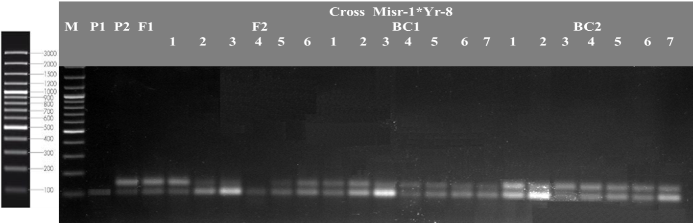
Figure 1: Amplification profile of the SSR marker Xgwm157, highlighting the DNA fragment associated with the Yr8 gene.

Likewise, microsatellite marker Barc8 amplified a 210bp DNA fragment associated with the Yr15 gene, confirming the presence of Yr15 in all genotypes except for one F₂ repeat and three repeats from both BC₁ and BC₂.
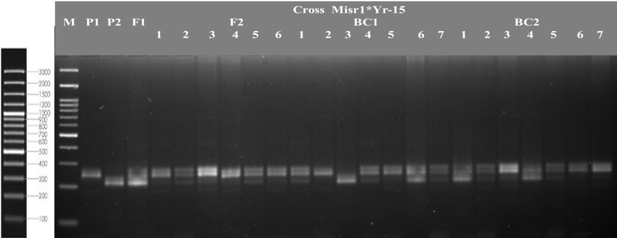
Figure 2: Amplification profile of the SSR marker barc8, highlighting the DNA fragment associated with the Yr15 gene.

Multivariate heat map:
The multivariate clustering analysis successfully differentiates wheat genotypes based on both morphological and molecular data, providing a framework for the selection of genotypes that exhibit desirable traits. The integration of field data with molecular markers like Yr8 demonstrates the potential of combining phenotypic and genotypic approaches to enhance the effectiveness of wheat breeding programs.
Multivariate clustering heatmap studies were employed to understand the interrelations among the six populations of both crosses (Misr1 x Yr8 and Misr1 x Yr15) by identifying the distinctions between the morphological and molecular data clusters as well as their interaction. A cluster heatmap was created using Euclidean distance and ward linkage through R software, as shown in Figure 3.

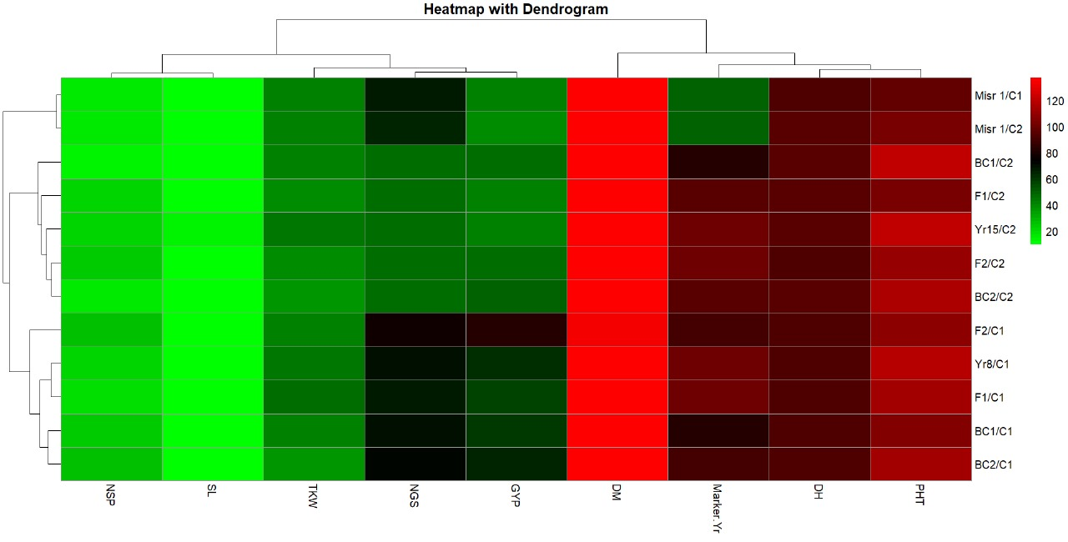
Figure 3. Multivariate heat map illustrating the genetic diversity of six population of cross (Misr 1 x Yr8) and (Misr 1 x Yr 15), a heatmap was generated based on a single SSR marker and eight field traits using the ClustVis module, an online tool for clustering and visualizing multivariate data (Tauno Metsalu et al., 2015).

The rows represent the genotypes, including parents (Misr 1, Yr8, and Yr 15), F₂, F₁, BC₁, and BC₂, derived from crosses "Misr 1 × Yr15" and "Misr 1 × Yr8," while the columns represent agronomic traits, including plant height (PH), days to heading (DH), marker Yr, days to maturity (DM), grain yield per plant (GYP), number of grains per spike (NGS), TKW (1000 Kernel Weight), spike length (SL), and number of spikes per plant (NSP).
Regarding the heat map, the studied traits were listed vertically into two clusters. Three groups in the first cluster contain the first group, which contains plant height (PHT) and days to heading (DH), whereas each of the markers, Yr and days to maturity (DM), fell into a single group.
The second cluster is divided into three groups. The first group includes grain yield per plant (GYP) and number of grains per spike (NGS), while 1000 kernel weight (TKW) is placed in a separate group. The third group consists of spike length (SL) and number of spikes per plant (NSP).
The genotypes representing the six populations of the two crosses were distributed horizontally into three clusters. The first cluster contains the genotypes Misr1 in cross 1 and Misr1 in cross 2, which is expected since they are the same parent; the second cluster contains the genotypes of Yr15, F₁, F₂, BC₁, and BC₂ of the second cross, while the third cluster contains the genotypes of Yr8, F₁, F₂, BC₁, and BC₂ of the first cross.
The color gradients (green to red) provide insights into the performance of each genetic structure for individual traits. Traits like plant height (PHT), days to maturity (DM), and days to heading (DH) exhibit predominantly red shades across most genetic structures, indicating consistently high values. This suggests these traits are stable and less influenced by genetic diversity in the studied lines. On the other hand, variable traits such as spike length (SL), 1000 kernel weight (TKW), and number of grains per spike (NGP) showed a broader spectrum of colors, from green to red. This highlights significant variability, making them potential targets for trait improvement and selection. It’s worth mentioning that the genotypes Yr15 and BC₁ in cross 2 showed unique patterns of performance, excelling in specific traits (spike length or kernel weight). These genotypes may harbor valuable alleles for improving these traits.

Biplots:
Biplots are used to display statistical results and provide clear insights into the traits and genotypes being studied. In previous studies (Azza et al., 2021; Zayed et al., 2022), biplots were utilized to represent and analyze different types of data. They help in classifying data by classifying genotypes based on all studied traits, whether molecular or morphological.
The PCA biplot revealed which of the 9 morpho-agronomic traits and 2 SSR primers contributed most to the differentiation of the examined genotypes (Figure 4). Based on these traits, the 12 genotypes were clustered into three groups. The first group included the genotypes from the cross Misr1 x Yr8: Yr8, F₁, F₂, BC₁, and BC₂. This group was primarily distinguished by 1000 kernel weight (TKW), number of spikes per plant (NSP), grain yield per plant (GYP), and number of grains per spike (NGS). The second group comprised the genotypes from the cross involving Yr15, F₁, F₂, BC₁, and BC₂, which were predominantly influenced by days to heading (DH), days to maturity (DM), plant height (PHT), and spike length. Meanwhile, the genotype (Misr 1) formed its own distinct group. These results are consistent with the findings from the heatmap analysis.

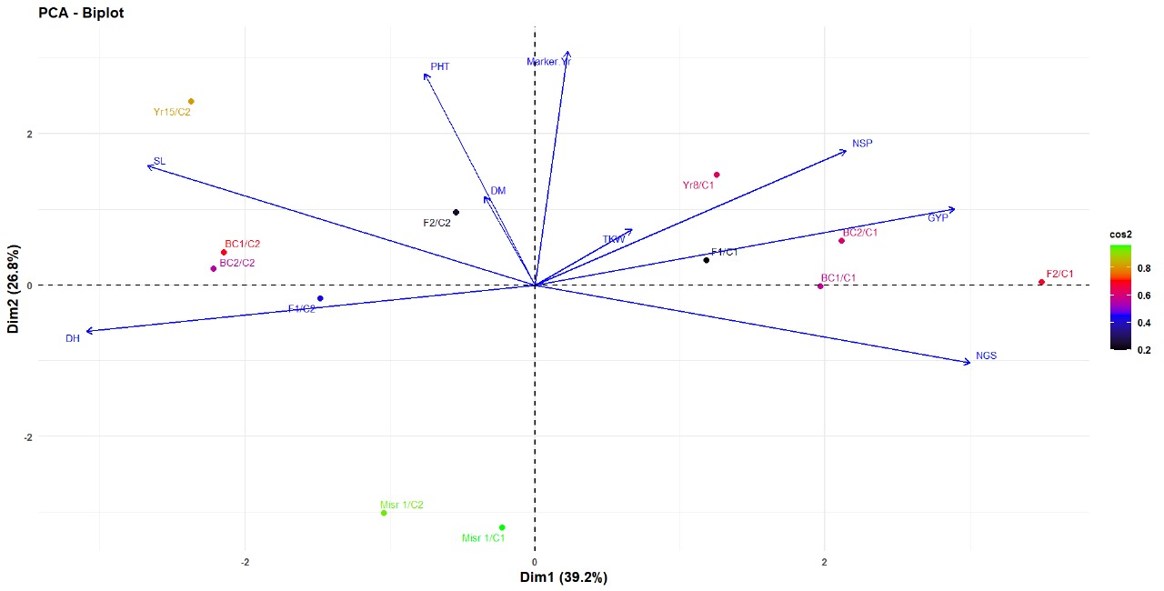
Figure 4. A biplot cluster tree depicting the genetic distance among twelve wheat genotypes, depending on the analysis of 8 morpho-agronomic traits and 2 SSR primers. The clustering was performed using the Euclidean distance and the UPGMA algorithm in PAST software.

The analysis of the heatmap and biplot reveals significant insights into the genetic diversity and trait relationships among the studied wheat populations. The clustering of traits and genotypes revealed that the traits; plant height (PHT), days to heading (DH), and days to maturity (DM) demonstrated strong positive correlations and stability across genotypes, suggesting their utility as reliable targets for breeding programs. Whereas variable traits like spike length (SL), 1000 kernel weight (TKW), and number of grains per spike (NGS) displayed broader variability, making them potential targets for improvement to enhance crop performance and yield.
The data showed that the genotypes were grouped based on their genetic background, with distinct clusters for hybrids derived from the Yr15 and Yr8 crosses. This highlights the influence of parental genotypes on trait performance and genetic diversity. The unique performance of genotypes such as Yr15 and BC₁ in cross 2 suggests the presence of valuable alleles for traits like spike length and kernel weight, which can be exploited in breeding programs. The biplot analysis confirmed the trait-based grouping of genotypes and their interaction with the environment. Genotypes from the same cross clustered together, emphasizing the genetic and phenotypic consistency within crosses. Genotypes influenced by traits such as 1000 kernel weight (TKW), number of spike per plant (NSP), grain yield per plant (GYP), and number of gain per spike (NGS) formed one group, while those affected by days to heading (DH), days to maturity (DM), plant height (PHT), and spike length (SL) formed another, reflecting their distinct genetic and environmental influences. The clustering patterns and trait relationships provide a roadmap for targeted selection and breeding. Stable traits like PHT, DH, and DM can serve as foundational traits for stabilizing crop performance, while variable traits like TKW and SL offer opportunities for enhancing yield and quality. The identified genotypes with unique trait performance, particularly Yr15 and BC₁ in cross 2, are promising candidates for further genetic improvement.

Conclusion:
Integrating Yr monogenic lines into breeding programs is a key strategy for improving resistance to yellow rust (Pst). Yr lines carry resistance genes targeting specific races of the rust pathogen, and incorporating these lines into local or commercial cultivars enhances wheat's ability to withstand rapidly evolving pathogen strains. By using different Yr lines in crosses, breeders can develop wheat varieties resistant to multiple yellow rust races, reducing the need for chemical fungicides and increasing crop stability. Furthermore, these resistance genes can be combined with other desirable traits, such as yield and grain quality, leading to overall improved wheat performance across diverse environmental conditions. Integrating Yr lines into breeding programs also involves modern genetic techniques, such as SSR (Simple Sequence Repeat) markers, to identify and track resistance genes in superior individuals. This integration of resistance genes with other agricultural traits offers significant potential for enhancing wheat productivity and reducing the impact of diseases on the yield.

References

Abd El-Rahman, M. E. (2013). Estimation of some genetic parameters through generation mean analysis in three bread wheat crosses. Alexandria Journal of Agricultural Research, 58(3), 183–195.
Abdalla, A., Stellmacher, T., and Becker, M. (2023). Trends and prospects of change in wheat self-sufficiency in Egypt. Agriculture, 13(1), 7. https://doi.org/10.3390/agriculture13010007
Afzal, S. N., Haque, M. I., Ahmedani, M. S., Bashir, S., and Rattu, A. R. (2007). Assessment of yield losses caused by Puccinia striiformis triggering stripe rust in the most common wheat varieties. Pakistan Journal of Botany, 39, 2127-2134.
Ahmed, B. H. (2021). Estimates of genetic parameters using six populations in two bread wheat crosses. Archives of Agriculture Science Journal, 4(1), 330-341.
Amin, I. A. (2013). Genetic behavior of some agronomic traits in two durum wheat crosses under heat stress. Alexandria Journal of Agricultural Science, 58(1), 53–66.
Ashmawy, M. A., and Ragab, K. E. (2016). Grain yield of some wheat genotypes to stripe rust in Egypt. Menoufia Journal of Plant Protection, 1, 9-18.
Azza, H. M., Omar, A. A., Attya, A. M., Elashtokhy, M. M. A., Zayed, E. M., and Rizk, R. M. (2021). Morphological and molecular characterization of some Egyptian six-rowed barley (Hordeum vulgare L.). Plants, 10(11), 2527. https://doi.org/10.3390/plants10112527
El-Aref, K. A. O., Tammam, A. M., Ibrahim, M. M., and Koubisy, Y. S. I. (2011). Generation mean analysis in bread wheat under drought conditions. Egyptian Journal of Applied Sciences, 26(2), 187–208.
El-Gammaal, A. A., and Yahya, A. I. (2018). Genetic variability and heterosis in F1 and F2 generations of diallel crosses among seven wheat genotypes. Journal of Plant Production, 9(12), 1075–1085.
Feng, J., Wang, M., See, D. R., Chao, S., Zheng, Y., and Chen, X. (2018). Characterization of novel gene Yr79 and four additional quantitative trait loci for all-stage and high-temperature adult-plant resistance to stripe rust in spring wheat PI 182103. Phytopathology, 108, 737–747. https://doi.org/10.1094/PHYTO-11-17-0375-R
Fethi, B., and Mohamed, E. G. (2010). Epistasis and genotype-by-environment interaction of grain yield-related parameters in durum wheat. Plant Breeding and Crop Science, 2(2), 24-29.
Gamble, E. E. (1962). Gene effects in corn (Zea mays L.). I. Separation and relative importance of gene effects for yield. Canadian Journal of Plant Science, 42, 339-348.
Hamam, K. A. (2013). Estimation of genetic parameters using five populations model in three bread wheat crosses under normal irrigation and drought stress. Journal of Plant Breeding, 17(2), 63-79.
Hamam, K. H. (2014). Genetic analysis of agronomic parameters in bread wheat using six parameters model under heat stress. Egyptian Journal of Agronomy, 36(1), 1-18.
Hammer, Ø., Harper, D. A. T., and Ryan, P. D. (2001). Past: Paleontological statistics software package for education and data analysis. Palaeontologia Electronica, 4(1), 9pp. http://palaeo-electronica.org/2001_1/past/issue1_01.htm
Hayman, B. I., and Mather, K. (1955). The description of gene interaction in continuous variation. Biometrics, 10, 69-82.
Hendawy, H. (2003). Genetic architecture of yield and its components and some other agronomic parameters in bread wheat. Menoufia Journal of Agricultural Research, 28(1), 71-86.
Hochholdinger, F., and Yu, P. (2024). Molecular concepts to explain heterosis in crops. Trends in Plant Science. https://doi.org/10.1016/j.tplants.2024.07.018
Johnson, V. A., Biever, K. G., Haunhold, A., and Schmidt, J. W. (1955). Inheritance of plant height, yield of grain, and other plant and seed characteristics in a cross of hard red winter wheat (Triticum aestivum L.). Crop Science, 6, 336-338.
Kalendar, R., Boronnikova, S. and Seppänen, M. (2021). Isolation and Purification of DNA from Complicated Biological Samples. In: Besse, P. (eds) Molecular Plant Taxonomy. Methods in Molecular Biology, vol 2222. Humana, New York, NY. https://doi.org/10.1007/978-1-0716-0997-2_3
Kearsey, M. J., and Pooni, H. S. (1996). The genetical analysis of quantitative traits. Chapman and Hall.
Khaled, M. A. I. (2013). Genetic system controlling the yield and its components in three bread wheat (Triticum aestivum L.) crosses. Egyptian Journal of Agricultural Research, 91(2), 641–653.
Khalid, A., Hameed, A., and Tahir, M. F. (2023). Wheat quality: A review on chemical composition, nutritional attributes, grain anatomy, types, classification, and function of seed storage proteins in bread making quality. Frontiers in Nutrition, 10. https://doi.org/10.3389/fnut.2023.1053196
Khattab, S. A. M., Esmail, R. M., and Abd Al-Ansary, E. M. F. (2010). Genetic analysis of some quantitative traits in bread wheat (Triticum aestivum L.). New York Science Journal, 3(11), 152–157.
Koumber, R. M., and El-Gammaal, A. A. (2012). Inheritance and gene action for yield and its attributes in three bread wheat crosses (Triticum aestivum L.). World Journal of Agricultural Sciences, 8(2), 156-162.
Kuobisy, Y. S. I. (2011). Generation mean analysis in bread wheat under drought conditions (M.Sc. thesis). Faculty of Agriculture, Al-Azhar University, Assuit, Egypt.
Manal, H. E. (2009). Estimation of heritability and genetic advance of yield traits in wheat (Triticum aestivum L.) under drought condition. International Journal of Genetics and Molecular Biology, 1(7), 115-120.
Martínez-Moreno, F., Giraldo, P., Nieto, C., and Ruiz, M. (2022). Resistance to leaf and yellow rust in a collection of Spanish bread wheat landraces and association with ecogeographical variables. Agronomy, 12, 187. https://doi.org/10.3390/agronomy12010187
Mather, K. (1949). Biometrical genetics (1st ed.). Methuen and Co.
Metsalu, T., and Vilo, J. (2015). ClustVis: A web tool for visualizing clustering of multivariate data using principal component analysis and heatmap. Nucleic Acids Research, 43(W1), W566–W570. https://doi.org/10.1093/nar/gkv468
Mohamed, A. I. K. (2013). Genetic system controlling the yield and its components in three bread wheat (Triticum aestivum L.) crosses. Egyptian Journal of Agricultural Research, 91(2), 641.
Mousaa, A. M. (2010). Estimation of epistasis, additive and dominance variation in certain bread wheat (Triticum aestivum L.) crosses. Journal of Plant Production, Mansoura University, 12, 1707-1719.
Nsabiyera, V., Bariana, H. S., Qureshi, N., Wong, D., Hayden, M. J., and Bansal, U. K. (2018). Characterisation and mapping of adult plant stripe rust resistance in wheat accession Aus27284. Theoretical and Applied Genetics, 131, 1459–1467. https://doi.org/10.1007/s00122-018-3090-x
Peter, F. C., and Frey, K. J. (1966). Genotypic correlation dominance and heritability of quantitative characters in oats. Crop Science, 6, 259-262.
Raikwar, R. S., Mishra, A., and Shukla, K. C. (2024). Estimation of genetic components for yield and quality characters in five diverse wheat (Triticum aestivum L.) crosses by six parameter model. International Journal of Advanced Biochemistry Research, 8(4), 443-447.
Said, A. A. (2014). Generation mean analysis in wheat (Triticum aestivum L.) under drought stress conditions. Annals of Agricultural Sciences, 59(2), 177–184. https://doi.org/10.1016/j.aoas.2014.11.003
Sari, D., Sari, H., Ikten, C., and Toker, C. (2023). Genome-wide discovery of di-nucleotide SSR markers based on whole genome re-sequencing data of Cicer arietinum L. and Cicer reticulatum Ladiz. Scientific Reports, 13(1), 10351. https://doi.org/10.1038/s41598-023-37268-w
Sharma, S. N., Sain, R. S., and Sharma, R. K. (2003). The genetic control of flag leaf length in normal and late sown durum wheat. The Journal of Agricultural Science, 141, 323-331.
Tauno, M., and Vilo, J. (2015). ClustVis: A web tool for visualizing clustering of multivariate data using principal component analysis and heatmap. Nucleic Acids Research, 43(W1), W566–W570. https://doi.org/10.1093/nar/gkv468
USDA. (2024). Grain: World markets and trade (p. 23).
Walid, M. E.-O., Ashmawy, M. A., Shahin, A. A., and Ahmed, M. I. (2020). Screening of CIMMYT wheat genotypes against yellow rust in Egypt. International Journal of Phytopathology, 9(01), 51-70. https://doi.org/10.33687/phytopath.009.01.3269
Zaazaa, E. I., Hagerand, M. A., and El-Hashash, E. F. (2012). Genetical analysis of some quantitative traits in wheat using six parameters genetic model. American-Eurasian Journal of Agricultural & Environmental Sciences, 12(4), 456–462.
Zayed, E., Ghonaim, M., Attya, A., Morsi, N., and Hussein, K. (2022). IRAP-PCR technique for determining the biodiversity between Egyptian barley cultivars. Egyptian Journal of Botany, 62(2), 359-370. https://doi.org/10.21608/ejbo.2021.93071.1768
Zhang, M., Saimi, A., Liu, Q., Ma, Z., and Chen, J. (2023). The detection of Yr genes in Xinjiang wheat cultivars using different molecular markers. International Journal of Molecular Sciences, 24(17), 13372. https://doi.org/10.3390/ijms241713372

